Newton St Cyres Parish Council
Bank Balances as at 29 October 2025

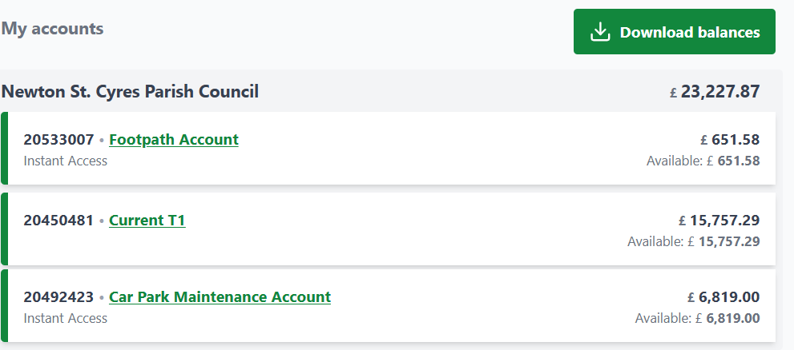

I confirm that the bank balances above agrees with the financial accounts balance as at the above date
Signed: ___________________ J Hole, Clerk
Date: _____________________

